|  |
| --- |
| CS 370 Current/Emerging Trends |
| 7-3 Project Two |
| Emily Wood |

|  |
| --- |
| emily.wood7@snhu.edu  4-16-2023 |

**Analyze the differences between human and machine approaches to solving problems.**

* **Describe the steps a human being would take to solve this maze.**

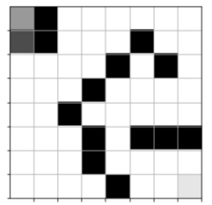

A human would move randomly through the maze until they hit a block. At that point they would turn around and try a different direction. This process would repeat until they reach the end of the maze.

* **Describe the steps your intelligent agent is taking to solve this pathfinding problem.**

The agent utilizes exploration and exploitation to solve this problem. About 10% of the time, with exploration the agent tries to improve its knowledge about each action (up, down, left, right) to make the best overall decision. With exploitation, the agent tries to get the most reward by using the currently known information (Yang, 2022). This is done hundreds of times until the best solution is created through maximum rewards.

* **What are the similarities and differences between these two approaches?**

Humans don’t see rewards usually until the end and very rarely remember all the steps it took to get there unless they are writing something down. So, in this case it becomes an “all or nothing” approach. With the agent, everything becomes incremental. Humans and agents both use exploration to discover the state of the environment.

**Assess the purpose of the intelligent agent in pathfinding.**

* **What is the difference between exploitation and exploration? What is the ideal proportion of exploitation and exploration for this pathfinding problem?**

With exploitation, the agent chooses an action based on its knowledge of the current environment that maximizes its rewards. With exploration, the agent chooses an action with no regard for possible reward with the sole purpose of learning more about the environment. You cannot exploit without exploring. The epsilon parameter is between 0.0 and 1.0, but the one generally used is 0.1. This means for every 10 attempts, nine will exploit its current knowledge and one time will be pure exploration. I tried different epsilon parameters for the maze to see how the algorithm performed.

**Epsilon = 0.1:**

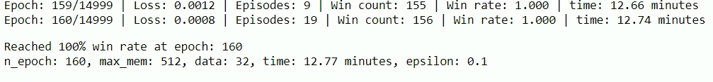

**Epsilon = 0.3:**



**Epsilon = 0.5:**



**Epsilon = 0.7:**



**Epsilon = 0.9:  
I stopped this one after an hour because the win rate did not exceed 53%**

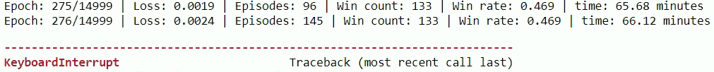

* **How can reinforcement learning help to determine the path to the goal (the treasure) by the agent (the pirate)?**

“Reinforcement Learning is about learning the optimal behavior in an environment to obtain maximum reward. This optimal behavior is learned through interactions with the environment and observations of how it responds” (Verma & Diamantidis, 2021). Rewards are granted based on the actions taken. Positive rewards are granted for moves that bring the agent closer to the destination. Negative rewards are given to previously visited locations, roadblocks, etc. The maximum number of rewards is given to the agent once the destination is reached.

**Evaluate the use of algorithms to solve complex problems.**

* **How did you implement deep Q-learning using neural networks for this game?**

Each action receives a reward.

After each game, an episode is generated based on the environment state, the action, the reward received from the action, and the new environment state based on the previous action. After each move in the game, the episode is stored in the memory. After each move, a random selection of the most recent episodes is used in the neural network. Rewards are granted and the best path is determined (Zafrany, 2018). 90% of the time, the model decides to exploit its previous learnings and 10% of the time, it explores new routes.

**References:**

Yang, A. (2022, July 25). *What is exploration vs. exploitation in reinforcement learning?* Medium. Retrieved April 10, 2023, from https://angelina-yang.medium.com/what-is-exploration-vs-exploitation-in-reinforcement-learning-a3b96dcc9503

Verma, P., &amp; Diamantidis, S. (2021, April 27). What is reinforcement learning? – overview of how it works. Synopsys. Retrieved April 10, 2023, from https://www.synopsys.com/ai/what-is-reinforcement-learning.html

Zafrany, Z. (2018, December 12). Deep reinforcement learning for maze solving. qmaze. Retrieved April 10, 2023, from https://www.samyzaf.com/ML/rl/qmaze.html